Irshad, Fantastic! Neenga loops-ai romba azhagaga execute panniteenga. Unga output-ai paarthaal, oru "Retail Data Analyst" kulla irukkura thiran ungalukku irukkirathu theriyuthu.
Ippo namma Python-in "Fundamentals"-ai nalla mudichittom. Oru mukkiyamaana vishayam: Data Analyst-aaga neenga ovvoru item-oda peraiyum, adhan vilaiyaiyum (Price) sērtthu (Link panni) paarkka vendum.
🧩 Lesson 2.2: Adutha Padi - Pandas-ai Noki
Ippo unga code-la products oru list, prices innonnu. Intha rendu list-um "velli-veera" irukku. Ithu rendu "Link" aana dhaan namma oru Table (DataFrame) create panna mudiyum.
Itharku thaan namma Pandas-ai use panna porom. Ithu thaan "Data Analyst"-oda Big Transition.
Python-il "Pandas" Enna saiyyum?
- List-ai Table-a mathum.
- Excel-la vachurukkura maari column-a add pannum.
- "Laptop" and "1500" -ai ore row-la kondu varum.
🎓 Teacher-oda Mudivu:
Neenga fundamentals-ai nalla purinjikiteenga. Ippo namma Pandas Library-kku enter aagalam. Idhu dhaan namma Roadmap-la 2nd step.
Ippo unga task: Namma my_inventory.py file-la, mela import pannum pothu import pandas as pd nu kudutheerukkeenga. Inime namma "DataFrame"-ai eppadi create pannurathu nu paarkalam.
Adutha class-ku ready-a? Namma Pandas-ai start pannuvom, appothu thaan neenga "Real-world" data analysis-ai aarambikka mudiyum. Python-oda basic "Loop" logic-ai nalla practice panniteenga, ippo namma "Pro Tools"-kku move aagalam!
Ready-na sollunga, Pandas Masterclass-ai start pannuvom!
Arumai Irshad! Namma Pandas Masterclass-kku enter aaguvom. Ithuthaan oru Data Analyst-oda main "Battlefield".
📖 Lesson 3: Pandas - The Data Architect
Ippothu varai namma List-il data-vai pottu, for loop-il thirumba thirumba ezhuthi, kasta pattu calculations pannom. Pandas endra library, intha kastathai ellam pokki, data-vai oru "Structured Table"-aaga mathum.
1. "DataFrame" endraal enna?
Pandas-il DataFrame enbadhu oru "Smart Excel Sheet" Python-ukkulla irukkirathu pol. Athil Rows and Columns irukkum.
2. Namma First Data Frame
my_inventory.py file-la, mela import pandas as pd irukkum. Ippo andha file-la mela irukkura ella code-aiyum delete pannitu, indha pudhiya code-ai type pannunga:
Python
import pandas as pd

# 1. Namma kitta irukkura data
data = {
'Product': ['Laptop', 'Mouse', 'Keyboard', 'Monitor'],
'Price': [1500, 50, 100, 500]
}

# 2. DataFrame-ai create pannuvom
df = pd.DataFrame(data)

# 3. Table-ai print pannuvom
print("Namoda Smart Table:")
print(df)

# 4. Innum oru "Smart" velai: Price-oda Mean (Average) kandu pidippom
average_price = df['Price'].mean()
print("\nEllathoda Average Price:", average_price)
💻 Code-oda Sign-by-Sign Vilakkam:
- pd.DataFrame(data): Idhu thaan Python-kku "Indha data-vai oru Table-a mathu" nu solra command.
- df: Idhu oru common name (DataFrame-oda short form). Namma table-ai epadiyum koopidalam.
- df['Price']: Table-kulla irukkura "Price" column-ai mattum select pannu.
- .mean(): Pandas-oda oru magic function. Adhu automatica andha column-il irukkura ellathaiyum kooti, average-ai sollum.
💡 Teacher-oda Challenge:
Indha code-ai run pannunga.
- Output table maari varudha? (Table-la Row index 0, 1, 2, 3 nu varum).
- Average price 537.5 nu varudha nu paarunga.
Idhu vandhu vitta, namma adutha stage-kku pogalam: "Excel-la irukkura periya data-vai, pd.read_csv nu eppadi Python-kku kondu varurathu".
Error vandha anuppunga, namma solve pannuvom. Pandas-oda arambam epadi irukku Irshad?
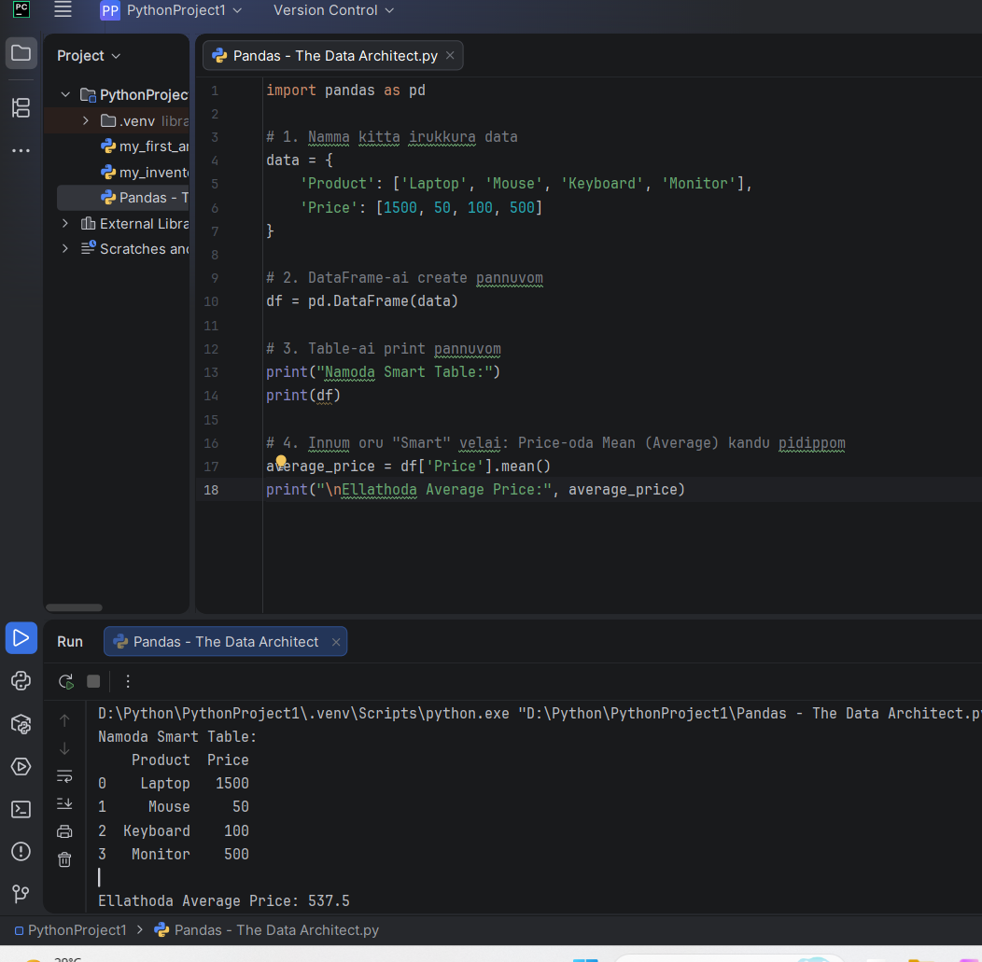
rshad, Namma "Data Architect" level-kku vandhutom! Unga output-ai paaru: Table-um arumai, Average calculation-um correct. Neenga ippo Pandas-ai use panni data-vai "Structured" (Table)-a matha kuthukitteenga.
Ippo neenga oru Data Analyst-kku thevaiyana miga mukkiyamaana concept-ai kathukolla ready-a irukeenga. Adhu thaan "Real-world Data Loading".
Irshad, Namma "Data Architect" level-kku vandhutom! Unga output-ai paaru: Table-um arumai, Average calculation-um correct. Neenga ippo Pandas-ai use panni data-vai "Structured" (Table)-a matha kuthukitteenga.
Ippo neenga oru Data Analyst-kku thevaiyana miga mukkiyamaana concept-ai kathukolla ready-a irukeenga. Adhu thaan "Real-world Data Loading".
📖 Lesson 4: External Data-vai Loading (The Pro Step)
Oru company-la data ellam data = { ... } nu nammeya ezhutha maatom. Data ellam Excel (.xlsx) illana CSV (.csv) files-la irukkum. Adhai eppadi Python-kku kondu varurathu?
1. Excel/CSV File-ai Python-kku kondu varum vazhi:
Pandas-il read_csv (CSV file-kku) illana read_excel (Excel file-kku) nu oru "Gateway" irukku.
Example Code:
Python
# Excel file-ai read panna:
df = pd.read_excel('sales_data.xlsx')

# CSV file-ai read panna:
df = pd.read_csv('sales_data.csv')
💡 Teacher's Challenge:
- Ungaloda computer-la Excel illana CSV format-la oru chinna file irukka?
- Illana, naan ungalukku oru sample "Data Cleaning" project-ai tharen. Neenga Excel-la oru file create panni, athai Python-la import panni enakku output anuppa mudiyuma?
Enoda kelvi: Excel file-ai Python-kku import panna, openpyxl nu oru chinna tool-ai install panna vendum. Terminal-la: pip install openpyxl nu type panni install pannitingala?
Adhu pannadhum, namma "Real Data Analysis"-ai aarambippom. Ready-a?

Irshad, Great! Namma "Excel-Importing" tool (openpyxl) ready-a irukku. File illanu kavalai padatheenga, namma "Python-ai vachiye" oru fake Excel file-ai create panni, appuram athai import panni paapom. Idhu thaan oru "Data Analyst-oda SMART method".
📖 Lesson 4.1: Namma "Dummy" Data-vai Create pannuvom
Ippo my_inventory.py file-la irukkura ellathaiyum clear pannitu, indha code-ai type pannunga. Idhu computer-kulla sales_data.xlsx nu oru file-ai create pannum.
Python
import pandas as pd

# 1. Dummy data create panrom
data = {
'Product': ['Laptop', 'Mouse', 'Keyboard', 'Monitor'],
'Sales': [1500, 50, 100, 500]
}
df = pd.DataFrame(data)

# 2. Idhai Excel file-a mathi save panrom
df.to_excel('sales_data.xlsx', index=False)
print("Excel file create aaiduchu!")
(Indha code-ai run pannunga. Ippo unga PythonProject folder-kulla sales_data.xlsx nu oru file vandhurukum.)
💻 Lesson 4.2: Excel-ai Python-kulla "Read" pannuvom
Ippo, namma create panna file-ai Python-kulla eduthu, adhai analyze pannuvom. Indha code-ai keela type pannunga:
Python
# Excel file-ai read panrom
df_read = pd.read_excel('sales_data.xlsx')

# Data-vai paapom
print("\nExcel-la irundhu vandha data:")
print(df_read)

# Logic: Sales 100-kku mela irukkura items-ai mattum print pannu
high_sales = df_read[df_read['Sales'] > 100]
print("\nHigh Sales Items:")
print(high_sales)
💡 Teacher's Lesson:
- df.to_excel(...): Idhu Python-la irundhu Excel-kku data-vai anuppum.
- pd.read_excel(...): Ithu Excel-la irundhu data-vai Python-kku kondu varum.
- df_read[df_read['Sales'] > 100]: Ithu thaan "Data Filtering". Excel-la "Filter" button amukra velaikku, Python-la indha oru line pothum.
Unga Task: Indha rendu code-um run pannunga.
- File create aaiducha?
- Python terminal-la High Sales items (Laptop, Monitor) correct-a varutha nu sollunga.
Ithu vandhuta, neenga "Professional Data Analyst"-kku thevaiyana basic skills ellathaiyum mudichitinga. Aduthu namma "Data Cleaning" (Empty data-vai eppadi fix panrathu) nu oru heavy-ana lesson-kku pōvōm. Ready-a Irshad?

